Product Name | Description | Product Image | Item Price |  | Quantity | Total Price
Farmers Club Silk Tie | Navy with logo |  |  | £25.00
Farmers Club Silk Tie | Green with logo |  |  | £25.00
Farmers Club Cuff Links | Navy with logo |  |  | £18.00
Farmers Club Lapel Badge | Navy and Green with logo |  |  | £10.00
Farmers Club Mug | White Bone China with  black logo |  |  | £12.50
Farmers Club Bag Hook | Handbag hanger to temporarily secure a purse or handbag to a table or armrest. |  |  | £6.50
Farmers Club Tote Bag | Hession bag with black handles & Club Logo |  |  | £10.00
Leather Gifts - All the leather gifts come in their own presentation box and are created from a Cowhide
Leather called "Cow Softie" which is calf skin.
Wallet | Embossed with logo | 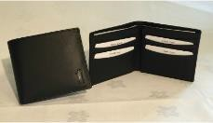 |  | £50.00
Cardholder | Embossed with logo | 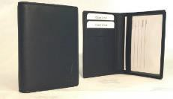 |  | £18.00
Luggage Tag | Embossed with logo |  |  | £15.00
Ladies Folding Umbrella | Green with white logo on panel |  |  | £17.50
Golf Umbrella | **Available for Collection only** |  |  | £30.00
Food Book | Food at  The Farmers Club |  |  | £29.00
History Book | The Farmers Club 1842-2017 |  |  | £25.00
Poncho Style Wrap / Blanket | Grey with logo 100% lambswool | 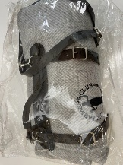 |  | £99.00

Postage & Packing - Standard Royal Mail will be used unless otherwise requested. Multiple item orders and signed for delivery requests will be subject to higher postage & packing rates. The golf umbrella is for collection at the Club Reception only. Please select one option below:
Single Item Order | UK Postcode |  | £ 5.00
Single Item Order | Overseas |  | £ 10.00
Other Postage Request | Special Delivery/Courier etc | The Club will contact you on receipt of your order to confirm postage rate
 | Total Cost |  |  | £
The total cost of your order will be charged to your Club Membership Account and will appear on your monthly statement.
Please call the Finance Team (020 7930 3557) to settle your account
Please provide the delivery address and your daytime telephone number in case we need to contact you regarding your order.
Name of Recipient
Address Line 1
Address Line 2
Address Line 3
Address Line 4
Address Line 5
Postcode
Daytime Telephone Number

