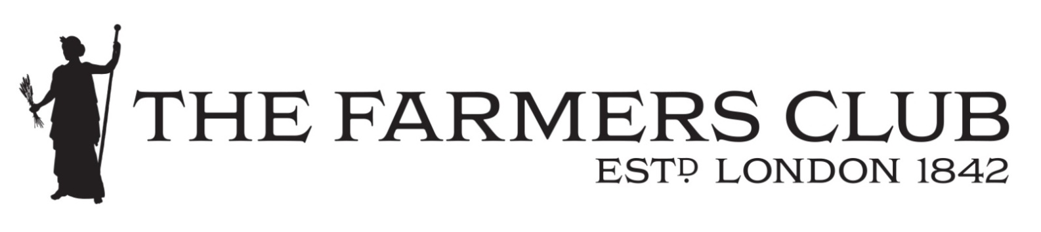

DATA PROTECTION
PRIVACY POLICY

THE FARMERS CLUB

Privacy Policy
At The Farmers Club, we’re committed to protecting and respecting your privacy. This Policy explains when and why we collect personal information about our members when they join the club, when they visit our website or book onto one of the many activities the club organises. The policy sets out how we use it, the conditions under which we may disclose it to others and how we keep it secure.
We may change this Policy from time to time so please check this page occasionally to ensure that you’re happy with any changes. By using our website, you’re agreeing to be bound by this Policy.
Any questions regarding this Policy and our privacy practices should be sent by email to aspence@thefarmersclub.com or by writing to The Chief Executive/Secretary, The Farmers Club, 3 Whitehall Court, London SW1A 2EL. Alternatively, you can telephone 0207 930 3751.

Who are we?
We are The Farmers Club, which is a private members club providing facilities and a programme of educational, professional and social events to our members who are predominantly members of the farming sector or associated industries within that sector. We also provide events venues for hire to those outside the membership when capacity allows on a commercial basis. The club has on average, 5,400 at any one time.

How do we collect information from you?
We obtain information about you when you apply to join the club as a member, and upon acceptance, further information is required. We also collect information when you use our website, for example, when you contact us about availability of rooms, places at events or reading the news items.

What type of information is collected from you?
The personal information we collect might include your name, address, email address, IP address, and information regarding what pages are accessed and when. If you reserve a place on one of our events, your card information is not held by us, it is collected by our third-party payment processors, who specialise in the secure online capture and processing of credit/debit card transactions, as explained below.

How is your information used?
We may use your information to:
- process a request or reservation you have made;
- to carry out our obligations arising from any contracts entered into by you and us;
- seek your views or comments on the services we provide;
- notify you of changes to our facilities and services;
- send you communications which you have requested or that may be of interest to you. These may include information about events, trips, lectures or significant changes to club policy/committee elections etc;
- highlight activities and advertisements of farming related items/activities from organisations outside the Farmers Club;
We review our retention periods for personal information on a regular basis and we will hold your personal information on our systems for as long as is necessary for the relevant activity or purposes relevant to club business or for as long as you are a member of the Farmers Club.

Who has access to your information?
- The Farmers Club will not sell or rent your information to third parties.
- We will not share your information with third parties for marketing purposes.
Third Party Service Providers working on our behalf: We may pass your information to our third-party service providers, agents subcontractors and other associated organisations for the purposes of completing tasks and providing services to you on our behalf (for example organisation of foreign and UK trips by parties of the Farmers Club). However, when we use third-party service providers, we disclose only the personal information that is necessary to deliver the service and we have a contract in place that requires them to keep your information secure and not to use it for their own direct marketing purposes. Please be reassured that we will not release your information to third-parties for them to use for their own direct marketing purposes unless requested to do so, or we are required to do so by law, for example, by a court order or for the purposes of prevention of fraud or other crime.

Your choices
You have a choice about whether or not you wish to receive information from us. If you do not want to receive direct communications from us relating to our activities, please inform us of this fact.

How you can access and update your information
The accuracy of your information is vitally important to us and we would ask that if you change email address, or any of the other information we hold is inaccurate or out of date, please email us at: membership@thefarmersclub.com, or write to us at: The Farmers Club, 3 Whitehall Court, London, SW1A 2EL. Alternatively, you can telephone 0207 930 375.
You have the right to ask for a copy of the information that The Farmers Club hold about you free of charge.

Security precautions in place to protect the loss, misuse or alteration of your information
When you give us personal information, we take steps to ensure that it’s treated securely. Any sensitive information (such as credit or debit card details) is encrypted and protected with sha256 (256 Bit) encryption on SSL. When you are on a secure page, a lock icon will appear on the bottom of web browsers such as Microsoft Internet Explorer.
Non-sensitive details (your email address etc.) are transmitted normally over the Internet, and this can never be guaranteed to be 100% secure. As a result, while we strive to protect your personal information, we cannot guarantee the security of any information you transmit to us, and you do so at your own risk. Once we receive your information, we make our best effort to ensure its security on our systems. Where we have given (or where you have chosen) a password which enables you to access certain parts of our websites, you are responsible for keeping this password confidential. We ask you not to share your password with anyone.

Profiling
We may analyse your personal information to create a profile of your interests and preferences so that we can contact you with information relevant to you.

Use of 'cookies'
Like many other websites, The Farmers Club website uses cookies. 'Cookies' are small pieces of information sent by an organisation to your computer and stored on your hard drive to allow that website to recognise you when you visit. They collect statistical data about your browsing actions and patterns and do not identify you as an individual. For example, we use cookies to store your country preference. This helps us to improve our website and deliver a better and more personalised service.
It is possible to switch off cookies by setting your browser preferences. Turning cookies off may result in a loss of functionality when using our website.

Links to other websites
Our website may contain links to other websites run by other organisations. This privacy policy applies only to our website‚ so we encourage you to read the privacy statements on other websites you visit. We cannot be responsible for the privacy policies/practices of other sites even if you access them using links from our website.
In addition, if you linked to our website from a third-party site, we cannot be responsible for the privacy policies and practices of the owners and operators of that third-party site and recommend that you check the policy of that third-party site.

Review of this Policy

We keep this Policy under regular review. This Policy was last updated in May 2018.

