**THE FARMERS CLUB**

**CHRISTMAS CARD ORDER FORM 2023**

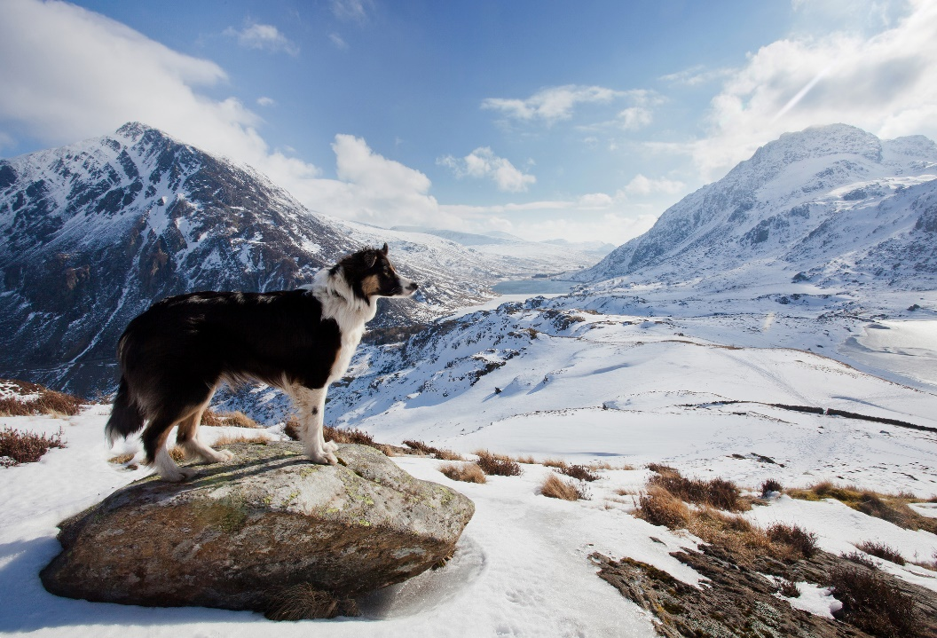

***“Gazing out over snow covered mountains”***

***Credit: Phil Corley goldenorfephotography/Getty Images***

**The Farmers Club Christmas Card** features an original photograph of a Border Collie looking out across snow covered mountains in the Ogwen Valley, Tryfan, Llyn Idwal, Pen Yr Ole Wen, Snowdonia.

The card, which measures 171mm x 121mm (6.75" x 4.75"), is printed with the Club logo and the greeting “With Best Wishes for Christmas and the New Year”. A percentage from the sale of the cards will be donated to R.A.B.I. of England, Wales and N. Ireland and the R.S.A.B.I. of Scotland, both of which are dedicated to helping members of the farming community facing hardship. The card is available in packs of 10 and may be bought at Reception or ordered from the General Office: generaloffice@thefarmersclub.com / 020 7930 3751.

|  |  |
| --- | --- |
| I would like ___________(Qty) packs of Christmas Cards at £8.50 per pack | **£** |
| Please add postage costs - all postage is 2nd Class Royal Mail Mainland only unless requested:  1-3 packs @ £1.90, 4 packs @ £2.40, 5-12 packs @ £2.99, 13-20 Packs @ £5.69 | **£** |
| **Total** | **£** |
| **PAYMENT DETAILS**:  **Cheques made payable** to “The Farmers Club”  **Bank transfer details:** Name: The Farmers Club, Sort Code: 16-00-38, Account No: 00299917, **Reference: “Xmas”**  Please deliver to the address below **OR** I will collect the cards from Reception on …………………………………………… | |
| Name ………………………………………………………………………………………………………………………………………………………………….. | |
| Address …………………………………………….…………………………………………………………………………………………………………………. | |
| ……………………………………………………………………………………………………………………………………………………………………………… | |
| ……………………………………………………………………………………………………………………………………………………………………………… | |
| Tel No ………………………………………………………………………………………………………………………………………………………………….. | |
| Email …………………………………………………………………………………………………………………………………………………………………… | |